**REQUIREMENT ANALYSIS**

TEMPERATURE SENSOR.

PRESSURE SENSOR.

RAIN SENSOR.

ESP8266 (NODE MCU).

CLOUD COMPUTING.

THINGSPEAK IOT CLOUD.

**Crop Protection Management: Methods & Strategies**

There exist various crop protection strategies, tools, and products. Moreover, the industry is constantly evolving, providing farmers with more and more effective methods of pest control. The choice depends on the area being farmed. Here are the most popular culture protection techniques.

**Weed Management**

Weeds are one of the major enemies of plants. They compete with them for nutrients, water, and space. As weeds are often aggressively growing and spreading plants, they can suppress and even destroy young plants. Proper protection of crops from weeds requires not only timely detection of the threat but also an understanding of the biological characteristics involved. You can use EOSDA Crop Monitoring to detect an affected zone and send scouts to analyze the situation.

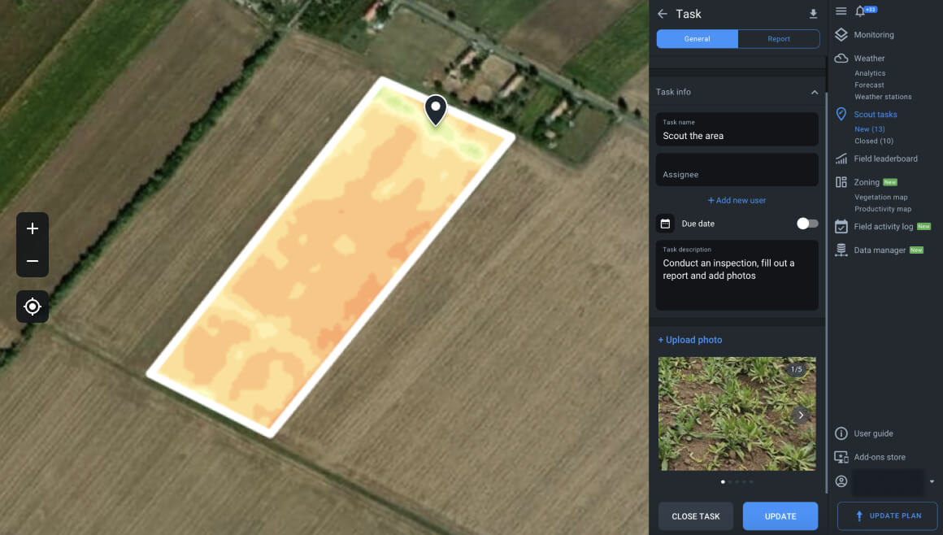Detection of abnormal NDVI level in EOSDA Crop Monitoring for weed control.

Crop protection from weeds involves preventive and control measures. The former include quarantine as well as [special seed treatment](https://eos.com/blog/seed-treatment/) and storage conditions. The latter include culture rotation, the use of herbicides, tillage, the production of competitive forage cultures, etc.

**Disease Management**

It is one of the most complex crop protection practices because various factors can influence diseases: plant age, genetics, environmental conditions, weather, etc. Consequently, it can be challenging to diagnose a disease, especially in the early stages of infection. It is, therefore, crucial to monitor the health of the plants regularly and analyze symptoms that occur sooner rather than later.

You can protect your yield against diseases by using one of the following methods:

* the application of chemicals;
* culture rotation;
* deep plowing;
* organizing quarantine;
* cultivation of disease-resistant species;
* heat treatment;
* regular monitoring of plant conditions.

Temperature stress is a frequent [plant disease](https://eos.com/blog/crop-diseases/) cause. EOSDA Crop Monitoring provides up-to-date weather forecasts and historical data that allow users to analyze trends and react preventively to extreme temperature fluctuations. For example, creating drainage to divert moisture during heavy rains or providing additional irrigation during droughts.

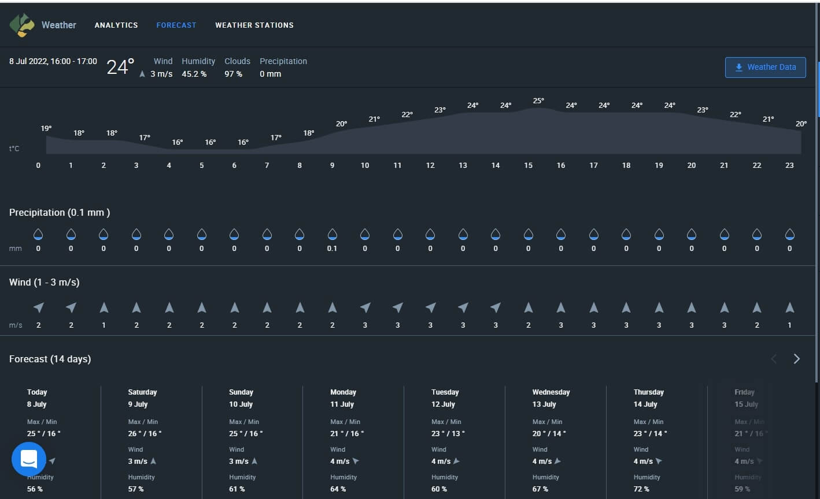Using forecasts of temperature, precipitation, wind to prevent plant diseases.

**Pest Management**

Protection of crops against pests means reducing pests and creating the most adverse conditions for their adaptation. Although some insects do not pose an economic threat to production, they can be disease vectors. Farmers should therefore protect crops from pests even if there is no immediate threat of culture damage. This type of yield protection may include the following methods:

* biological control;
* culture rotation;
* scouting.

Integrated crop protection (use of several strategies) is the most effective. It involves monitoring and preventing damage. In this way, farmers can reduce the number of pests and prevent the spread of diseases. So, high yields can be achieved.

**Crop Rotation Management**

Culture rotation is one of the most valuable and versatile crops protection methods. However, not all cultures are equally tolerant of the practice. For example, [corn](https://eos.com/products/crop-monitoring/crops/corn/) can be planted in the exact location for up to five years. On the other hand, [rye](https://eos.com/products/crop-monitoring/crops/rye/), [wheat](https://eos.com/products/crop-monitoring/crops/wheat/), and sugar beet react negatively to double cropping but can produce higher yields if properly rotated. It is why farmers sometimes do not even use a three-field but a six-field system. EOSDA Crop Monitoring makes it easy to monitor plant rotation by providing data on the order in which cultures are grown in specific areas.

Field history in EOSDA Crop Monitoring.

**Irrigation System Optimization**

The proper [soil moisture](https://eos.com/blog/soil-moisture/) level has a crucial influence on plant health and yields. To determine this, you need to consider rainfall and irrigation measures and the topography. A lack or, conversely, an abundance of moisture can weaken cultures and encourage the growth of weeds. Thus, farmers must use preventive measures to protect crops. EOSDA Crop Monitoring uses the NDMI vegetation index to identify problem areas that suffer from a deficiency or excess moisture. It enables platform users to optimize irrigation management.

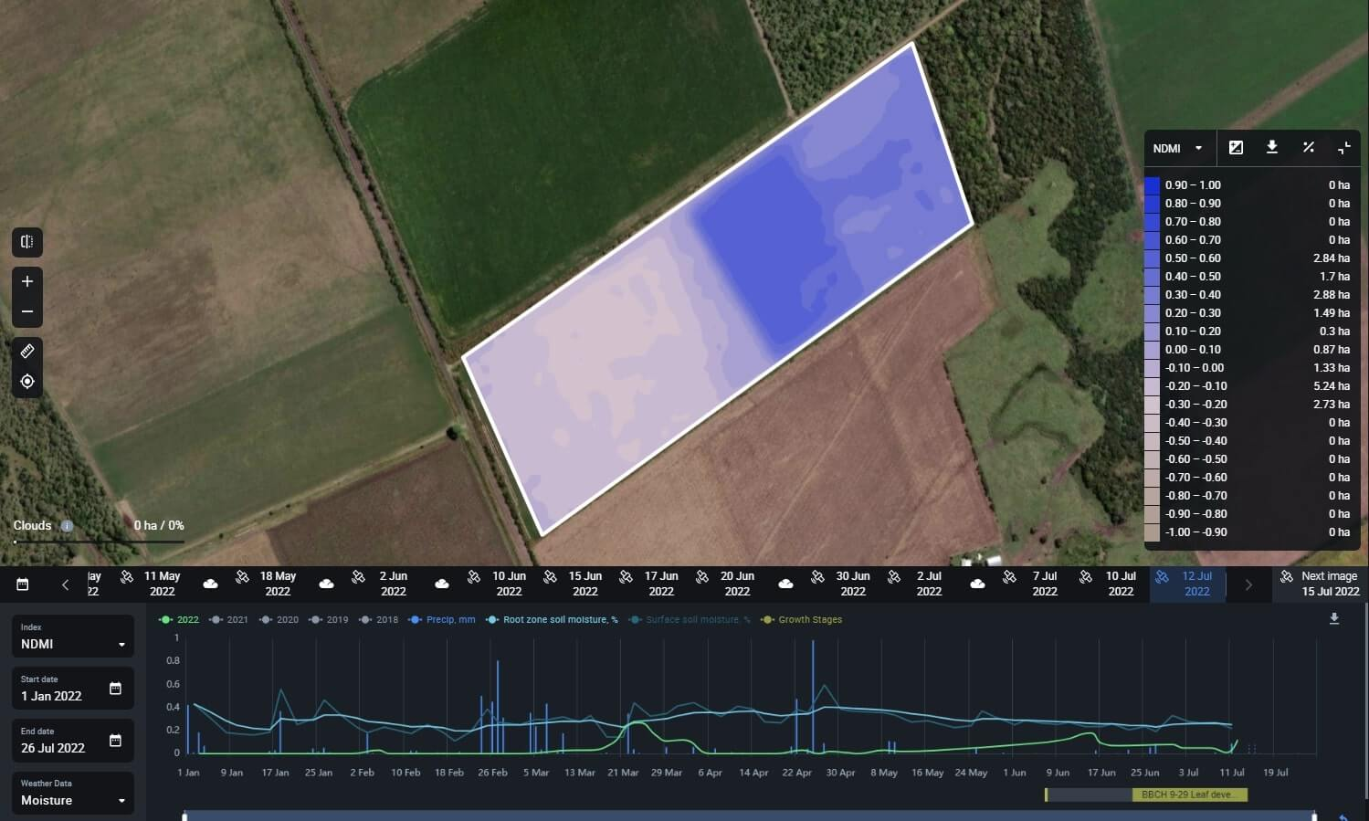Planning irrigation activities, based on soil moisture detection on EOSDA Crop Monitoring.

**EOSDA Crop Monitoring Ag Industry Solutions To Protect Crops**

An increasing world population is demanding ever more significant quantities of food. So efficient use of resources is critical to maximizing yields from each field. Today’s technologies make it possible to protect crop yields and **increase production outputs and product quality**.

Crop protection solutions use AI to collect and analyze large amounts of data. It provides farmers with detailed culture and soil conditions for plant protection planning. EOSDA Crop Monitoring is an excellent example of the helpfulness of remote sensing for crop protection. The platform effectively takes care of the health of the soil, reducing the risk of plant diseases and pests. Moreover, it provides data on plant health, moisture levels, and weather changes.

*EOSDA will soon launch its first*[*EOS SAT satellite constellation*](https://eos.com/eossat/)*targeting the agricultural industry. It will enable EOSDA Crop Monitoring to update satellite imagery more frequently and provide up-to-date information on the state of the fields.*

With field monitoring, agricultural cooperatives and large farms can analyze the productivity of their land over the past five years. It enables them to plan culture rotation. The platform is not only suitable for farmers but also for service providers and [input suppliers](https://eos.com/products/crop-monitoring/input-suppliers/). For example, pesticide manufacturers can test chemicals on particular fields, visually evaluating their crop protection performance. Insurance companies can monitor their clients’ fields to determine the [causes of crop damage](https://eos.com/industries/agriculture/crop-damage-assessment/) and objectively assess the quality of agricultural work. For example, reduced yields due to pest activity or disease require farmers to treat their fields accordingly. If they have not done so, insurance companies may reduce the payments on the policy.

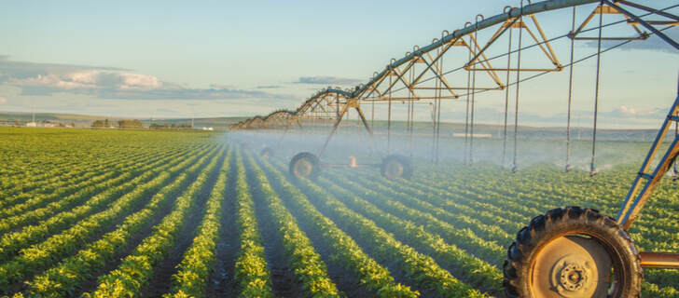

Using crop protection technologies for preventive actions is more effective than tackling a problem that has already occurred. In particular, it saves a great deal of effort and money. With EOSDA Crop Monitoring, you can monitor the essential parameters of agricultural production: field conditions and weather changes. This way, it’s possible to identify the most dangerous risks and create individual work plans, including preventive steps.

*EOSDA Crop Monitoring allows you to prevent plant diseases by providing current data on rainfall, temperature, moisture, and soil conditions. In the event of an infestation, you can identify such problem areas right away, using several vegetation index maps.*

**Crop Protection And The Environment**

Chemical products for culture protection can be harmful for the environment, so governments regulate their use at a legal level. For example, the U.S. Environmental Protection Agency has developed federal regulations based on an environmental risk analysis. The incorrect use of pesticides can cause severe damage to the environment. Sustainable crop protection is, therefore, the best solution to ensure nature conservation, resource-saving, and high yields. Modern technologies allow achieving these goals most effectively.

Thus, crop protection is an essential element of agriculture, without which it is impossible to obtain stable yields yearly. No matter what threat you are fighting, plant protection management must be carefully planned and include a variety of practices to ensure the best outcome. Modern technologies such as remote monitoring will allow you to protect your yields and use resources as efficiently as possible.